**AIM:** Write a C program to arrange a series of numbers using Insertion Sort

**ALGORITHM:**

1. **Divide** the array into two halves recursively until each sub-array has one element.
2. **Conquer** by sorting the smaller arrays.
3. **Combine** the two sorted halves by merging them into a single sorted array.
4. Repeat the process until the entire array is sorted.

**CODE:**

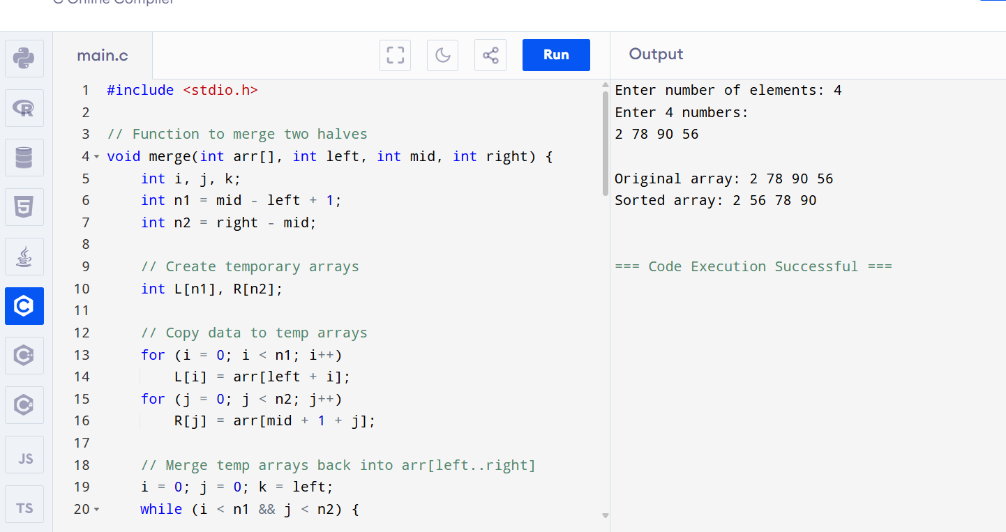

**OUTPUT:**

Enter number of elements: 4

Enter 4 numbers:

2 78 90 56

Original array: 2 78 90 56

Sorted array: 2 56 78 90